Chapter Officer Application

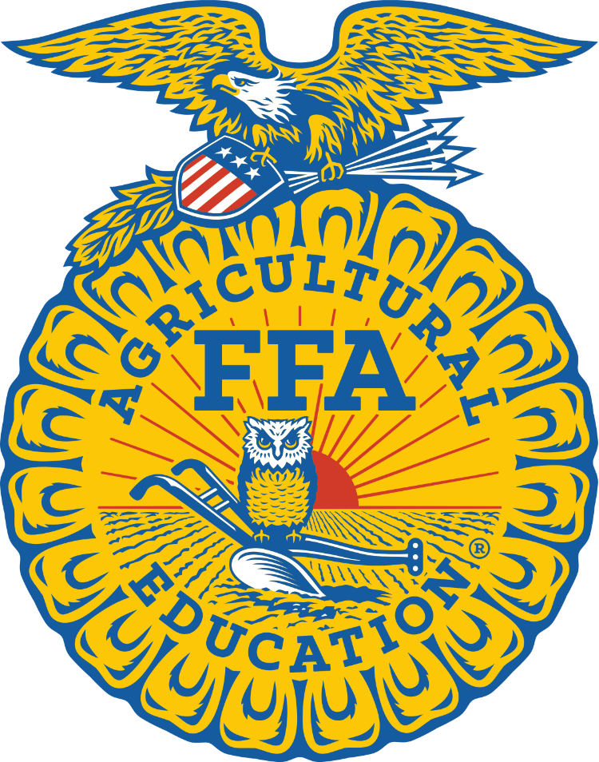

Smyrna FFA Chapter 2024-2025

Name: _______________________________________

RC Schools Email: _____________________________
Current Year in School: __________________________

Applications are due May 10, 2024. Interviews will be conducted the following week.
Chapter Officer Application
Please type or NEATLY print your responses.

(First) (Middle) (Last)

Which agriculture course(s) are you currently enrolled in?

What is your GPA?____________

Do you own official dress? ____ Yes ____ No

If “no”, would you be willing to purchase FFA official dress? ____ Yes ____ No

What FFA chapter office do you desire? _____________________________________

Why do you desire the particular office you have chosen?________________________
______________________________________________________________________
______________________________________________________________________
______________________________________________________________________
______________________________________________________________________

Please list any dates you plan to have vacation or are unavailable throughout the school year.__________________________________________________________________
______________________________________________________________________

Explain how you would serve as a positive influence on fellow FFA members, the school as a whole, and strive to be a leader in your community?_________________________
______________________________________________________________________
______________________________________________________________________
______________________________________________________________________
______________________________________________________________________
______________________________________________________________________
______________________________________________________________________
______________________________________________________________________
Is there anything that would keep you from performing your duties as a Smyrna FFA Chapter officer? ____ Yes ____ No
If “yes”, please explain____________________________________________________
______________________________________________________________________
______________________________________________________________________

Qualifications
To participate in the Smyrna FFA Chapter Officer program, officer candidates must meet all the eligibility requirements:
- Have and maintain a 3.0 GPA or higher
- Have and maintain a clean discipline record (no detention, ISS, OSS, RIP, etc.)
- Attend the chapter officer retreat, TBD by officer team
- Attend Tennessee FFA Leadership Camp, Doyle, TN
- Attend all Chapter meetings
- Be a member of the local FFA chapter for the current school year
- Attend TN State FFA Convention, Gatlinburg, TN
- Attend National FFA Convention, Indianapolis, IN
- Compete in at minimum 1 CDE or LDE

Required Activities Calendar
The following activities are required of all chapter officers. A description of the activities and calendar are as follows:
Activity Dates:
Smyrna FFA Banquet May 14, 2024
FFA Leadership Camp June 10-14, 2024
National FFA Convention October 23-26, 2024
FFA Week Activities February 15-22, 2025
State FFA Convention March 23-37, 2025
Smyrna FFA Plant Sale April 1, 2025- May 1, 2025
Chapter Fundraising Activities 2024-2025 School Year
Smyrna FFA Chapter Meetings 3rd Thursday of every month
Officer Meetings Dates to be determined by team
Service Projects Scheduled by officer team
Discipline
All Smyrna FFA Chapter Officers will be placed on behavior contracts for any of the offenses listed below. The Chapter Officer is allowed two chances to improve their behavior, with the third offense resulting in removal from the team.
Officer Team Offenses:
- Not abiding by the FFA Code of Ethics at any time.
- Unexcused absences: Anything but an illness or family emergency.
- Failure to complete assigned task: Not upholding a responsibility given as a Smyrna FFA officer.
- Failure to maintain a 3.0 or high GPA OR failure of any courses
Offenses resulting in immediate removal from Chapter Officer Team:
- Anything that could be considered a violation of the school’s zero tolerance policy.
- Absence from a chapter required event (determined by advisors).
- Defiance of an advisor
- Being given ISS, OSS, detention, RIP or any other school discipline infraction
***Note that an FFA Advisor reserves the right to make decisions regarding the removal of an officer from the team for any infractions including but not limited those listed above
Please list any FFA activities you have been involved with. _______________________
______________________________________________________________________
______________________________________________________________________
______________________________________________________________________
______________________________________________________________________

What has been your favorite FFA memory AND why? ___________________________
______________________________________________________________________
______________________________________________________________________
______________________________________________________________________
______________________________________________________________________
______________________________________________________________________

Why do you want to be a Smyrna FFA Chapter Officer AND why?__________________
______________________________________________________________________
______________________________________________________________________
______________________________________________________________________
______________________________________________________________________
______________________________________________________________________
______________________________________________________________________

Why should you be elected as a Smyrna FFA Officer over your peers? (If you have previously served as an officer, what did you accomplish that makes you deserving of a position again?) ________________________________________________________
______________________________________________________________________
______________________________________________________________________
______________________________________________________________________
______________________________________________________________________
______________________________________________________________________
What are your ideas to improve our chapter? __________________________________
______________________________________________________________________
______________________________________________________________________
______________________________________________________________________
______________________________________________________________________
______________________________________________________________________

What does servant leadership mean to you? __________________________________
______________________________________________________________________
______________________________________________________________________
______________________________________________________________________
______________________________________________________________________

How would you handle a situation in which you and another member of your officer team or another FFA member disagree about a situation, plan, or have different opinions about how situations should be handled?
______________________________________________________________________
______________________________________________________________________
______________________________________________________________________
______________________________________________________________________
______________________________________________________________________
______________________________________________________________________
______________________________________________________________________

What do you think is the most important and most meaningful characteristic of a great FFA student leader? _____________________________________________________
______________________________________________________________________
______________________________________________________________________
______________________________________________________________________
IF ELECTED TO SMYRNA FFA CHAPTER OFFICE, I WILL:
- Be dedicated and committed to FFA and the total program of education in agriculture.
- Be willing to commit time to Smyrna FFA officer activities.
- Become knowledgeable of agriculture, of education in agriculture, and of FFA.
- Project a desirable image of FFA at all times.
- Regularly and promptly perform all duties assigned to me.
- Strive to improve my ability to carry on meaningful and enjoyable conversations with individuals of all ages and walks of life.
- Accept and search out constructive criticism and evaluation of my total performance.
- Evaluate periodically my personality and attitudes, making every effort to improve myself.
As a Smyrna FFA Chapter Officer, I agree to also follow the following code of ethics:
- To forego use of all alcohol, tobacco, and drugs while involved in official or unofficial FFA activities.
- To treat all FFA members equally by not favoring one over another.
- To conduct myself in a manner that commands respect without any display of superiority.
- To maintain dignity while being personable, concerned, and interested in my contacts with others.
- To use wholesome language in all occasions.
- To maintain proper dress and good grooming for all occasions.
- To work in harmony with fellow FFA officers
- Serve as a member of the team, always maintaining a cooperative attitude.
- Be willing to take and follow instructions as directed by those responsible for me.
I realize that being an officer in the FFA is an honor and a privilege, but also holds many responsibilities. I promise that, if elected, I will strive to uphold my office to the best of my ability and will present myself, at all times, in a manner that will be a credit to Smyrna High School, Smyrna FFA, Tennessee State FFA Association and the National FFA Organization. I also understand that as a Smyrna FFA Officer I am required to attend ALL Chapter activities, conventions, and conferences. I understand that not adhering to these requirements could result in the loss of my chapter office and/or responsibilities and Advisor discretion can and will be used in the removal of chapter officers from the team. By signing this application, I hold that this application is true to the best of my knowledge and that I will fulfill all responsibilities of being a Smyrna FFA Officer.

Parent Signature___________________________________
Student Signature__________________________________
Date______________________________________________

